**Synopsis/Proof of Concept**

**Idea/Approach Details**

**Department category : Information & Technology**

**Problem statement :** Transport project provides Services to Shipper for their goods from one Place to other Place for that Carrier provide their Vehicle to take Shipper goods for their Desire Location. There are all types of Vehicles available which are categorized like - category, Subcategory. Client can see all category and subcategory and Choose vehicle for their Goods which are going to be dispatched. In this Project client can Bid their Price for Luggage and also Carrier has decided Price for their Vehicle for Transport!

**Team Id : TG000568**

**College Name : Rakshashakti University**

**Team Leader Name : Parmar Viral K.**

**College Code : U-0595**

**1) HOW WILL YOU SOLVE THE PROBLEM?**

* + We are building a Web Application to remove the concurrency between Shipper and Transport companies.
  + In our Web-app the Shipper can directly interact with Transport companies for Transporting their Goods to one place to another Place. In our web portal the Shipper can interact with transport companies and transport company can interact with their truck drivers to Move the Good Carrier.
  + In detail, Shipper has a right to choose which kind of vehicle they want to use to Transfer their Goods, Shipper will be posting their ad on web portal and transport companies will bid on the ad they are interested in and after that Shipper has list of bid to choose which transport company provided their desired Services/price.
  + System provide all information to shipper about their desired vehicle driver, helper and their all contact detail after successfully deal between shipper and Company’s.
  + Plus we have the facility of the System sending an E-Receipt to both of the user with all the details!

**Flowchart of The web-portal :**

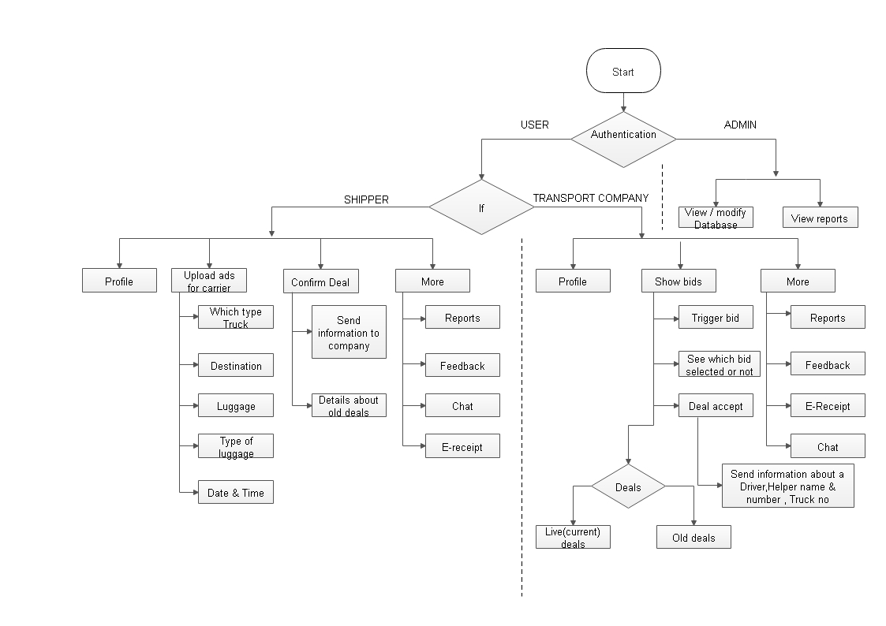

**2) Tools and Technology:**

* Window / Linux
* PHP (POP) 7.2.3
* HTML - 5
* CSS – 3
* JavaScript(Validation)
* MySQL – 5.0.12
* Apache - 2.4.29
* Atom - IDE
* Wire Shark
* Omnibug

**3) Possible outcome of your work**

* The outcome of the portal is that the Shipper would no longer need to go physically or negotiate with any transport company.
* It will minimize the man power (Digitalization).
* The whole process will be streamlined & secure (related to personal information of any Shipper and Transport company/ Shipper bid).
* It will reduce the wastage of time to search a vehicle.
* It will reduce time duration to complete the task and minimize the efforts of the Shipper and transporters (the Shipper doesn’t need to come again and again for transfer their good carriers).
* Shipper can directly search for the type of vehicle according to their requirement and which time or date they need to transfer their carrier to their desired Destination.
* System provides Login and registration security through the well known and used reCAPTCHA Technology, and the Web portal also provides OTP Authentication using email to identify user.

**4) Challenges/Risk in implementing your Final prototype:**

* A risk of implementing this particular prototype would be from the transport company’s side ie., the carrier. There could be fake registrations of the companies on the portal as there is no way a company can be verified unless we have a separate group of people working on that.

**5) Work done till date:**

* After comparing and examining the different present available websites and mobile applications made for the same purpose, we are trying to make a prototype which has the pros of them and have tried to dismiss the cons.
* The development of the portal designing is under completion.
* We are doing our best to build the best portal for the convenience of the transport companies as well the shippers and the task is almost 20-30% accomplished with the Front-End of the portal under the construction and we are trying our level best also to provide a best Back-End service for End-less Reliability.

----------